9.2. - Worksheet: Guidelines – Finding Practical Examples
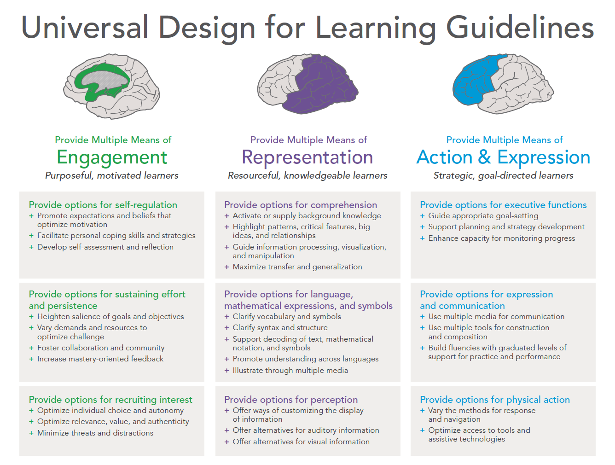

9.2. – Worksheet – finding practical examples
Universal Design for Learning Guidelines
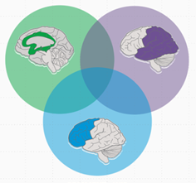
Learning

why

what

how

Why / PROCESS – Commitment and participation
Goals: Emotions and feelings during learning >> Independent and focused learning is possible
→ Motivational impulses for the subject matter + individual impulses = motivation to learn

What motivates you?
How can you concentrate well?
What do you need to be able to learn independently?

What / INPUT – Presentation and explanation
Objectives: Perception and senses, patterns and information are recognised
→ Offer different forms of presentation for content.

How should the learning information be prepared?
What do you need to understand the content well?

How / OUTPUT – Action and expression
Goal: Internalisation of knowledge and skills
→ Provide different ways of processing information and presenting learning outcomes
How do you best remember content?

