Identity Iceberg
Instructions:

Draw, write, or use stickers inside the iceberg.

Above the water: Things about you that people can see easily.
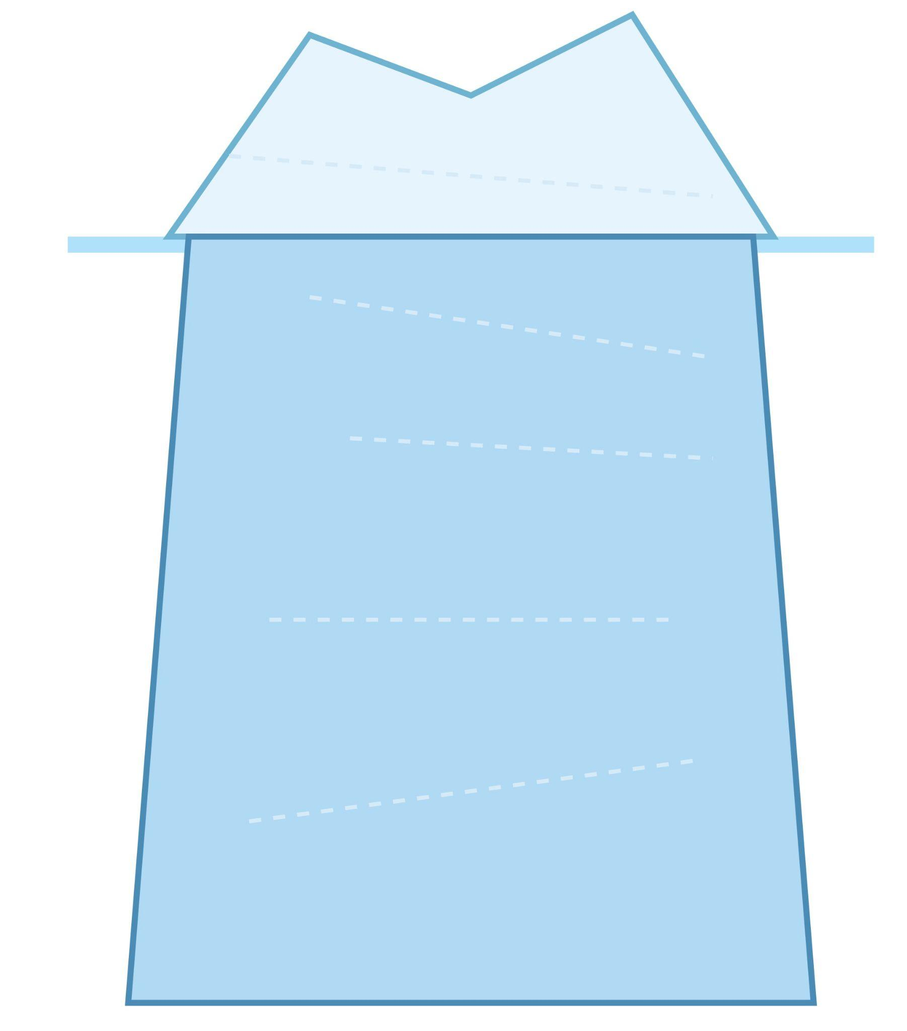
Below the water: Deeper things about you that are not always visible. (e.g. language, family, values, experiences, hobbies, dreams, feelings)

Above the Water

Water

Below the Water

Ideas for Above the Water:
- How you communicate (sign language, speech)
- What you look like
- Behaviors, school, clothing

Ideas for Below the Water:
- Family, culture, identity
- Values, beliefs, dreams
- Experiences, feelings, hopes, challenges
- Important people, memories, hobbies

Maslow’s Pyramid of Needs

Instructions:
Draw, write, or use stickers inside each level of the pyramid.
What helps you feel safe, happy, and confident as a Deaf person?

You can use symbols, words, or pictures!

Your Pyramid

dreams, goals, identity
5. Self-Actualization

confidence, respect
4. Esteem

family, friends, community
3. Love / Belonging

feeling safe, support
2. Safety

food, sleep, health
1. Physiological

Ideas for Each Level:
1. Physiological: food, water, rest, health, hearing aids/CI
2. Safety: feeling safe at home/school, support, clear communication, no
bullying
3. Love/Belonging: friends, family, Deaf community, clubs, acceptance
4. Esteem: feeling proud, being respected, achieving goals
5. Self-Actualization: dreams, doing what you love, being your true self,
helping others
Draw or write your own ideas in each level!

Reflection Worksheet

After watching the video or story, think about these questions.
You can draw, write, or use stickers in the boxes!

1. Identity Iceberg

What is “above the water” for this person? (What do people see?) - Draw or write here…

What is “below the water” for this person? (Hidden or deeper things) - Draw or write here…

2. Maslow’s Pyramid

Which needs are easy for this person? - Draw or write here…

Which needs are hard for this person? - Draw or write here…

3. Barriers & Supports

What are some barriers (difficult things) for this person? - Draw or write here…

What are some supports (helpful things) for this person? - Draw or write here…

4. Connect to Yourself

Is there something in this story that is the same as your experience? - Draw or write here…

Is there something that is different from your experience? - Draw or write here…

